1 - click on correct combination
a - byte int long short
b - float char
c - double float boolean
d - char and boolean

Answer and Why? : Anwer is A. Because all of these data types can hold numeric data.

2 - Java save all object in which memory structure
a - Heap
b - stack
c - queue
d - Graph

Answer and Why? : Java stores all objects in Heap memory. So answer is A. Using HEAP will make it easy for object management and memory management.

3 – write 2 ways to create infinite loop?
Answer and Why? : In below do-while statement, we have given true value in while and so it will be infinite loop. While second example is for loop where we used i variable but not incremented it and so it will be infinite loop.
do {
//
} while(true);

for(int i=0; i < 10; ) {
//
}

4 – Method Overloading is a kind of
a – Compile Time Polymorphism
b – Runtime Polymorphism
c - Encapsulation
d – a and b both
Answer and Why? : Answer is D. As compile time it is verified. Also verification is done at run time.

5 – What is the output?
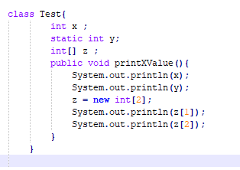
Answer and Why? : It will not print anything as printXValue method is not called.
Also there are issues in code. Eg. Index 2 of array z is called which will throw out of index exception.

6 – Write Sequence to initialize blocks
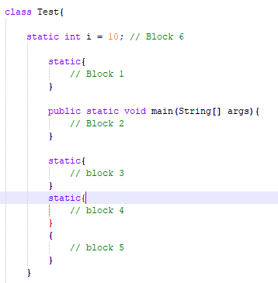
Answer and Why? : Block 1, Block 3, Block 4, Block 5, Block 6, Block 2.
Static blocks will get called first. Method will get called at last.

7 – Write Output of this Code
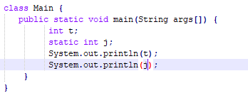
Answer and Why? : It will throw error for static variable j as it is declared in method.

8 - Write difference between
A - while, do…while and for loop.
Answer and Why? : do... while loop is executed at least once as condition is checked after execution.
For loop can be used when we know start and end value for iteration variable.
While loop can be used to match the condition which may not be known initially.

B – Encapsulation and Abstraction
Answer and Why? :Encapsulation is hiding the inner complexicty from user. While abstraction is on design level.

C – JDK and JRE
Answer and Why? : JDK is Java development kit and it includes JRE + development framework to use. Eg. Javac which is used to compile is part of JDK and help convert java code to machine language.
JRE is mainly used to execute machine language code.

D – Logical AND and bitwise AND
Answer and Why? : Logical AND can be used in conditions and returns boolean value.
Bitwise AND returns int value.

9 – What is result of below questions
X = 10
a – Y = X++ + ++X + ++X + X++ + X++
Answer and Why? :62

b – Y = X-- + --X + ++X +X++ + ++X
Answer and Why? :47

c – Y = X+++++X
Answer and Why? : Will throw error as operator + is extra.

10 – Result of Below Question
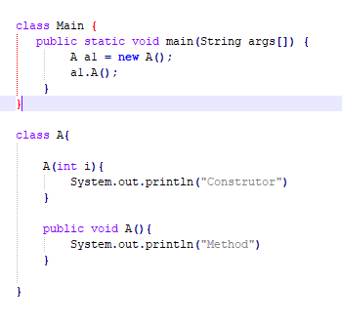
Answer and Why? : It will call constructor method A first for object creation and then second call made.
Method
Method

